STANDARD FORMAT OF “LEHENGA DESCRIPTION”


For Online Selling Products
Design Name: PRABHAT-A
Product Colours NO.: A3
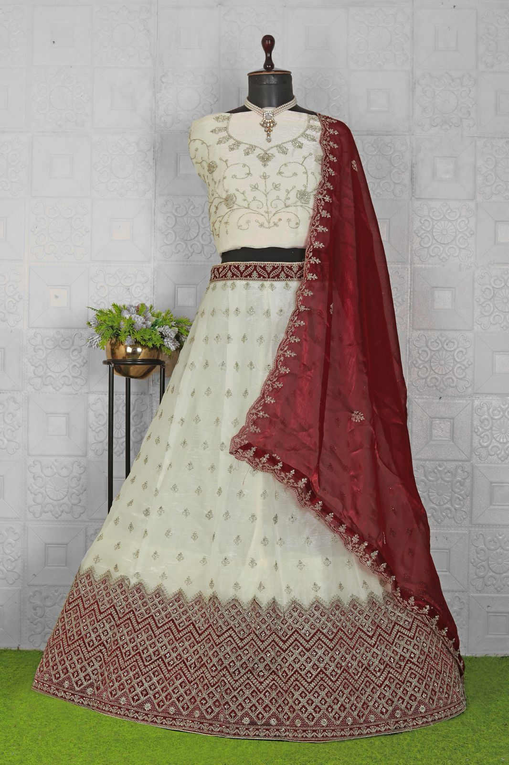
Particulars | Details
Lehenga Fabric | Burberry Silk
Blouse Fabric | Burberry Silk
Dupatta Fabric | Burberry Silk
Work Type | Jari & Stone
Colour | Maroon
Pattern | Girlish Designer Lehenga
Stitching Type | Semi-Stitched (Can be customized up to 44")
Occasion | Wedding, Reception, Engagement & Festive Wear
Fit Type | Regular Fit
Care Instructions | Dry Clean Only
Package Contents | 1 Lehenga, 1 Blouse Piece, 1 Dupatta

KEY HIGHLIGHTS
- Made from premium Burberry Silk fabric for a rich, smooth and elegant finish
- Matching Burberry Silk blouse and dupatta included
- Enhanced with fine Jari & Stone work for refined festive detailing
- Semi-stitched lehenga with 44” size for comfortable customization
- Ideal for festive wear, parties and special occasions
- Regular-fit design ensures comfort during long-duration wear
- Dry-clean-only maintenance for long-lasting shine and fabric quality

